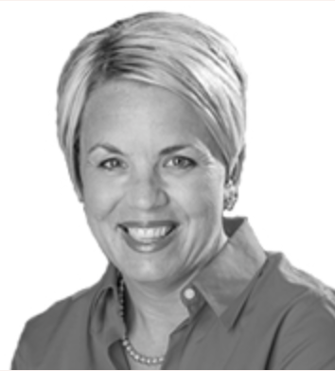
ABOUT ME
I have worked in the senior living world since 1995 in various settings from skilled nursing to assisted living. I have held various roles from activities, sales, operations, regional and corporate level positions. I am a Certified Recreational Therapist, a Certified Dementia Practitioner and a Certified Alzheimer’s Disease and Dementia Care Trainer for the National Council of Certified Dementia Practitioners (NCCDP).

I am passionate about teaching and facilitating a positive education seminar for the participants. I like to use an interactive teaching style. I like to engage participants to share their own stories and experiences in a manner that is fun and approachable.

I have presented at various state and national level conferences over the years. I am excited to offer this important NCCDP course to the community.
This is the required seminar for those who qualify and are interested to pursue Certified Dementia Practitioner. To see if you qualify for certification see www.nccdp.org

ALZHEIMER’S DISEASE AND DEMENTIA CARE SEMINAR
This is the required course to apply to become a Certified Dementia Practitioner with NCCDP

DETAILS
Wednesday, November 16th
Registration check in and light continental breakfast – 8:00-8:30
Class 8:30-5:00
Lunch – 12:00-1:00
To register: go to www.rachelleblough.com click on upcoming seminars
Select November 16th Clarendon Hills, IL Register and pay online to secure participation or call 614-581-9634 if paying by check
REGISTRATION CLOSES November 9th
Please note limited seating availability for this course. Act Early to secure your attendance
COST: $ 185.00
LOCATION
The Birches Assisted Living
215 55th St. Clarendon Hills, IL 60514

Thank you to The Birches Assisted Living for use of training classroom.
CEU’s approved for Acupuncturists, Counselors (Clinical/Professionals),Dental Hygienists, Dietitians/Nutritionists, Marriage and Family Therapists, Nurse Practitioners, Nurses (RNs/LPNs), Nursing Home Administrators, Occupational Therapists and COTAs, Physical Therapists and PTAs, Psychologists, Respiratory Care Therapists, Social Workers
Please select CEU option when registering

