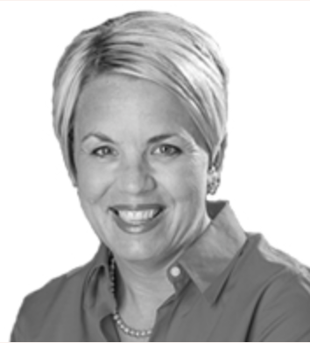
ABOUT ME
I have worked in the senior living world since 1995 in various settings from skilled nursing to assisted living. I have had various roles from activities, sales, operations, regional and corporate level positions. I am a Certified Recreational Therapist, a Certified Dementia Practitioner and a Certified Alzheimer’s Disease and Dementia Care Trainer for the National Council of Certified Dementia Practitioners (NCCDP).

I am passionate about teaching and facilitating a positive education seminar for the participants. I am not just a lecturer I like to use an interactive style, I like to engage participants to share their own stories and experiences in a manner that is fun and approachable.

I have presented a various state and national level conferences over the years. I am excited to offer this NCCDP course and to continue
to expand a
growing audience.
ALZHEIMER’S DISEASE AND DEMENTIA CARE SEMINAR
This is the required course to apply to become a Certified Dementia Practitioner with NCCDP
DETAILS
Friday June 23rd
Registration check in/
light continental breakfast – 8:00-8:30 Class – 8:30-5:00
Lunch – 12:00-1:00 – On your own restaurants near location
CEU’s approved for Acupuncturists, Counselors (Clinical/Professionals),Dental Hygienists, Dietitians/Nutritionists, Marriage and Family Therapists, Nurse Practitioners, Nurses (RNs/LPNs), Nursing Home Administrators, Occupational Therapists and COTAs, Physical Therapists and PTAs, Psychologists, Respiratory Care Therapists, Social Workers
Please select CEU option when registering if you will require them.

To register: go to www.rachelleblough.com upcoming seminars- (Chicago) Norridge IL and Register and pay online to secure participation or call 614-581-9634 if pay by check
– REGISTRATION CLOSES June 16th COST: $185.00

Instructor: Rachelle Blough CTRS, CDP, CADDCT

LOCATION
Central Baptist Village
4747 N. Canfield Ave
Norridge, IL 60705

This is the required seminar for those who qualify and are interested to pursue Certified Dementia Practitioner. To see if you qualify for certification see www.nccdp.org

